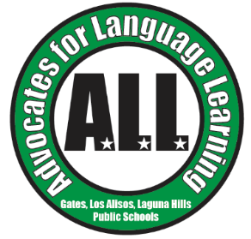**A.L.L. General Meeting Agenda**

**December 5, 2023**

* Topic: Bilingual Resources for Middle School, High School, and College Admissions
* **Call to Order**
* **Approval of Minutes**
* **Treasurer’s Report**
* **Principal Reports**
  + Gates Elementary
  + Los Alisos Intermediate
  + Laguna Hills High School
* **Middle School Socio-Emotional Support Presentation by Carmen Welsh, Los Alisos Intermediate School Community Liaison**
* **High School College Admissions Support and Resources by Elisa Manese, Saddleback College Counselor**
* **Executive Board Reports**
  + President, Leigh Hansen
    - A.L.L. Website Update
    - Oso Fit Fun Run
  + Vice President of Operations, Claudia Rodriguez Zinn
    - Carnaval
  + Vice President of Ways and Means, Silvia Lorena Flores
* **Upcoming Events:** 
  + Next General Meeting: Tuesday, February 6, 2024 at 6:30 PM via Google Meets, Topic: Senior Roundtable and 2024-25 Spanish Language Assistant
  + Carnaval Family Event: February 9, 2024, 5:30 - 8:00 at Los Alisos Intermediate
  + Oso Fit Fun Run/Walk: Saturday, February 24, 2024 8:30 AM at the Norman P. Murray Community Center in Mission Viejo
* **Other Business**
* **Adjournment**