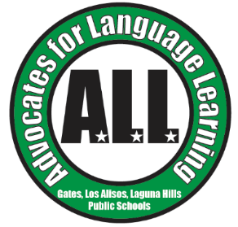**A.L.L. General Meeting Agenda**

**April 16, 2024**

* Topics: Immersion Benchmarks and Student Recognition Qualifications & Board Election for 2024-2025 School Year
* **Call to Order**
* **Approval of Minutes (Secretary, Cesi Vega)**
* **Election of A.L.L. Executive Board for 2024/2025 School Year (Nominating Committee Chairperson, Norma Drew)**
* **Principals’ Reports**
  + Gates
  + Los Alisos
  + Laguna Hills
* **Treasurer’s Report (Treasurer, Vanessa Aragon)**
* **Executive Board Reports**
  + President, Leigh Hansen
    - Need Volunteers: Festival de los Niños, 8th Grade Celebration, Senior Recognition Ceremony
  + Vice President of Operations, Claudia Rodriguez Zinn
    - Festival de los Niños
  + Vice President of Ways and Means, Silvia Lorena Flores
* **SVUSD Dual Immersion Benchmarks and Student Recognition Qualification (Maribel Herrera, ELD TOSA)**
* **Upcoming Events:** 
  + May 3, 2024 Festival de los Niños 4:00 - 7:00 at Gates Elementary
  + May 14, 2024 8th Grade Celebration 6:00 - 8:00 at Los Alisos Intermediate School - Blue Quad
  + May 16, 2024 Senior Recognition Ceremony 5:30 - 8:00 at the Laguna Hills Community Center
* **Other Business**
* **Adjournment**